**Report View**

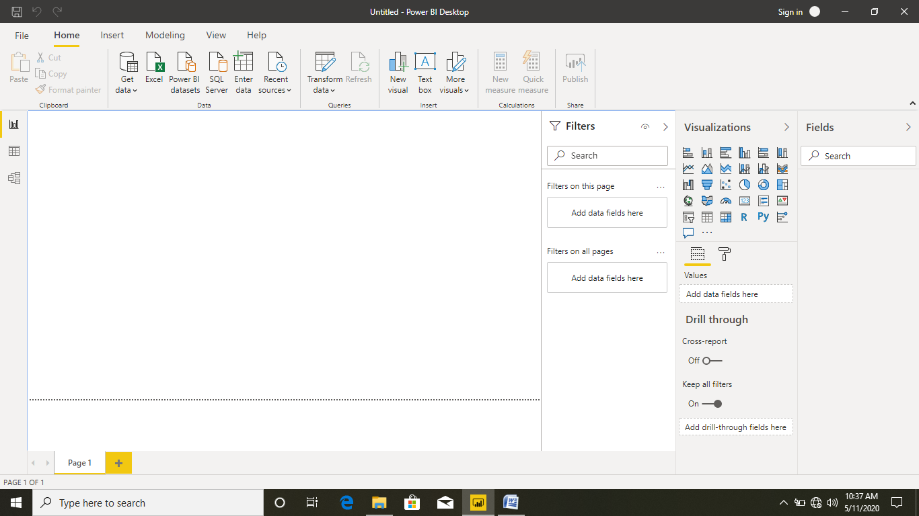

Report View is used to Display the Report display are used. Here we can **get data** option to import the data source to connect the data files are used. Your selecting the data source file it will be open to **power query editor** file are open and alignment that file.

Fields Tab to display the List of Table, Visualization Tab to Display the report in Bar chat, Pie chat, Scatter plot and etc..Filter Tab to Filter out the data are used.

Data View

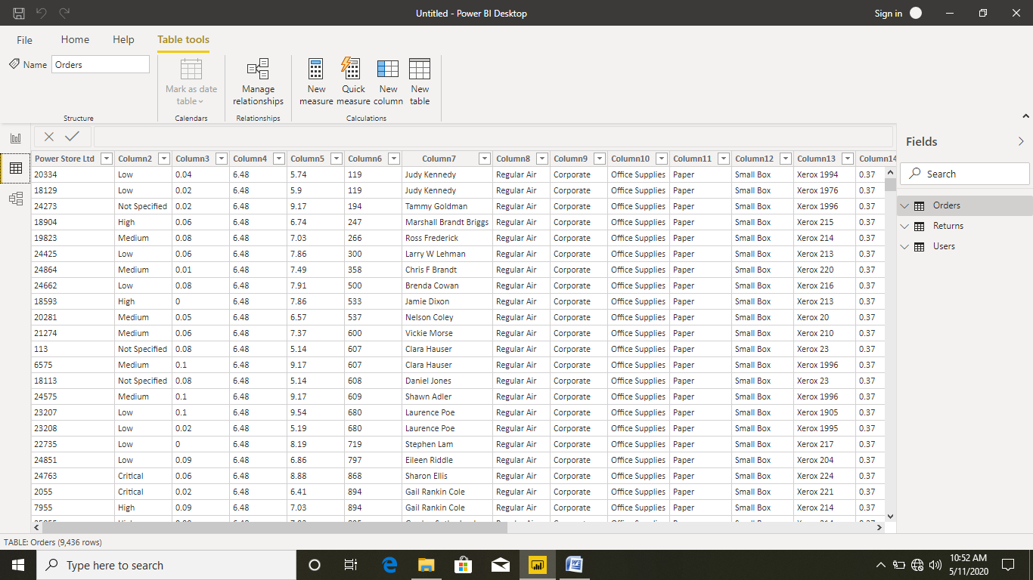

In Data View to Display table data in the form of Rows and Columns, here we can use the New Measures and Quick Measures option to do the calculation.

**Model View:**

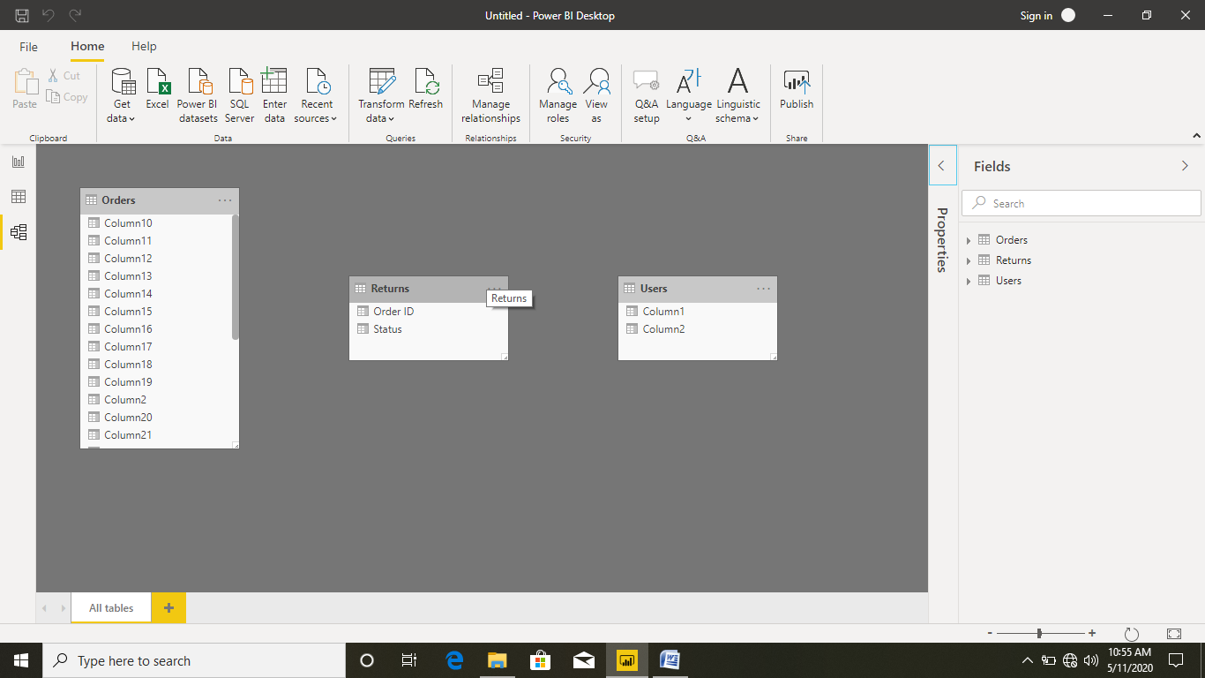

In Model View to display the dimension table and fact table relationship. That is one to one, one to many, many to many relationship are defined.

**Power Query Editor:**

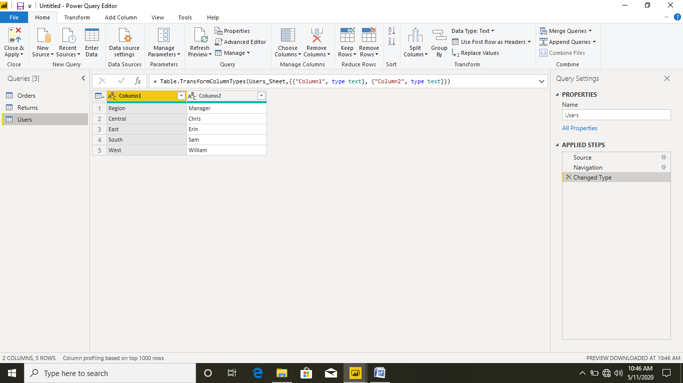

In Power Query Editor used to edit your table data that contains the blank null row are removing, Use the First Row as Header and alignment the column and row level are used. Here we can **Properties** to change the table name and **Applied Step** to change the data base table content are used.

**Advance Editor:**

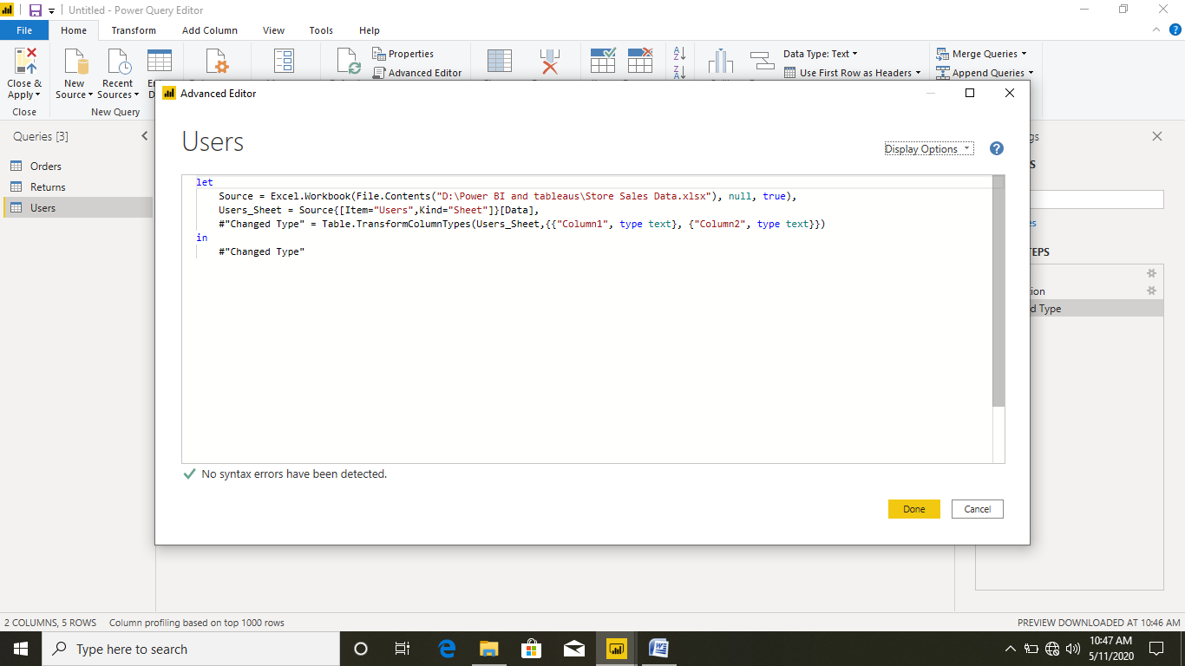

In Advance Editor Option used to write the query formulas for data manipulation.